**Cairo University Faculty of Computers and Artificial Intelligence**



**Machine Learning**

**Assignment1**

**Project Team**

|  |  |
| --- | --- |
| **ID** | **Name** |
| 20210382 | Maryam Abd El-Hamid Ibrahim |
| 20210072 | Alaa Hossam Mohammed |
| 20210348 | Mohamed Fathi Sayed |
| 20210229 | Abdel-Rahman Mohamed Ahmed |
| 20210388 | Mostafa Ahmed Mohamed |

**b) Perform analysis on the dataset to:**

* check whether there are missing values

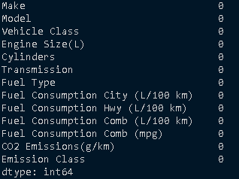

* check whether numeric features have the same scale

* visualize a pair plot in which diagonal subplots are histograms

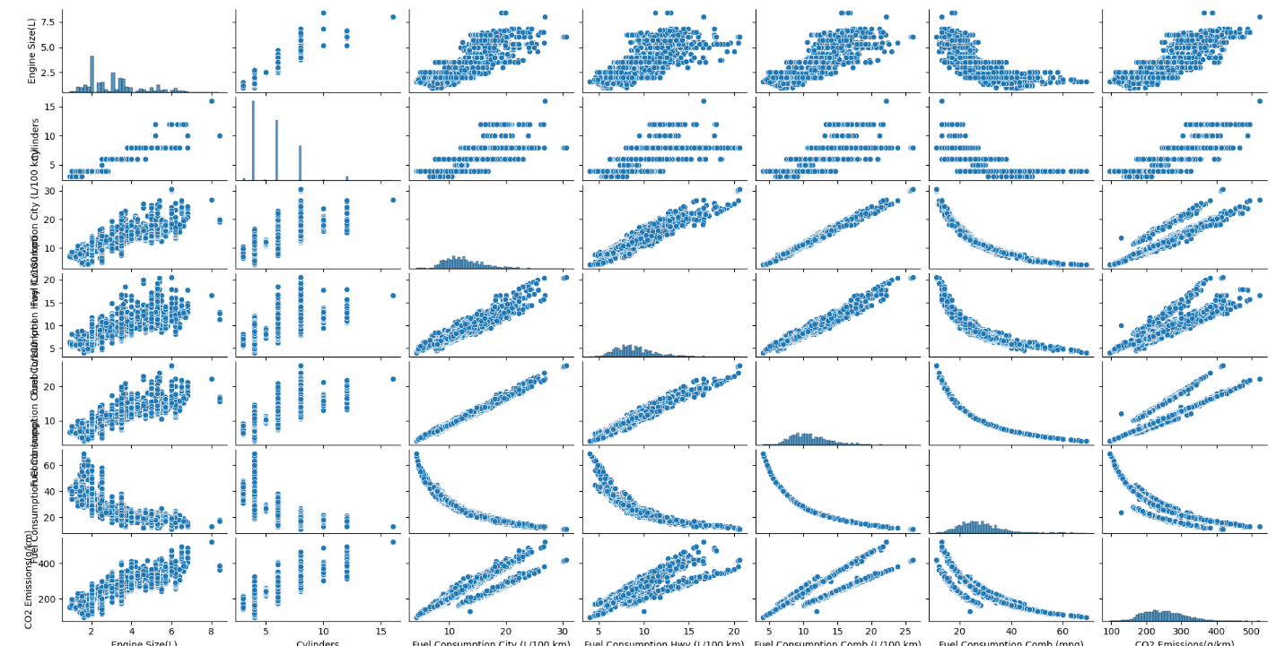

* visualize a correlation heatmap between numeric columns

**c) Preprocess the data such that:**

* the features and targets are separated

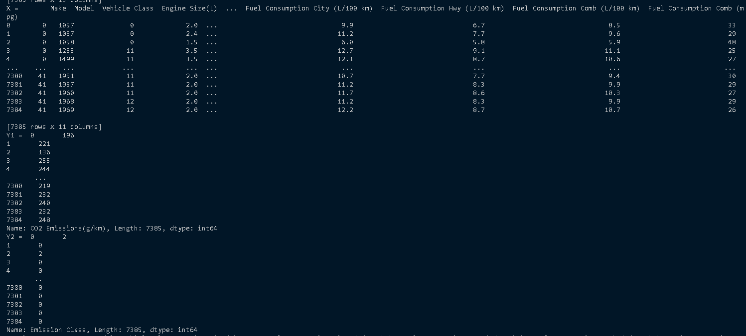

* categorical features and targets are encoded

* the data is shuffled and split into training and testing sets

* numeric features are scaled
* A blue screen with white text

  Description automatically generated

**d) Implement linear regression using gradient descent from scratch to predict the CO2 emission amount.**

* Based on the correlation heatmap, select two features to be the independent variables of your model. Those two features should have a strong relationship with the target but not a strong relationship with each other (i.e. they should not be redundant).
* Selected features : Fuel Consumption Comb (L/100 km), Engine Size(L)
* Calculate the cost in every iteration and illustrate (with a plot) how the error of the hypothesis function improves with every iteration of gradient descent.

* Evaluate the model on the test set using Scikit-learn’s R2 score.

**e) Fit a logistic regression model to the data to predict the emission class.**

* Use the two features that you previously used to predict the CO2 emission amount.
* **The Code:**

x_test = xTest[['Fuel Consumption Comb (L/100 km)', 'Engine Size(L)']].to_numpy()

* we choose ‘Fuel Consumption Comb (L/100 km)', 'Engine Size(L)' because they have strong relation between CO2 emission amounts (Fuel Consumption Comb (L/100 km)' with percentage 92%, 'Engine Size(L) with percentage 85%)
* The logistic regression model should be a stochastic gradient descent classifier.
* **The Code:**

def run_log(self):  
 lg = SGDClassifier(max_iter=500, loss='log_loss')  
 lg.fit(self.x_train,self.y_train)  
 y_pred = lg.predict(self.x_test)  
 return y_pred

In Main  
  
plt.figure(figsize=(8, 6))  
sns.heatmap(confusion_matrix(y2_test, y_pred, labels = [0,1,2,3]), annot=True, fmt='d', cmap='Blues',  
 xticklabels=['HIGH', 'LOW', 'MODERATE', 'VERY LOW'], yticklabels=['HIGH', 'LOW', 'MODERATE', 'VERY LOW'])  
  
plt.xlabel('Predicted' ,labelpad=20)  
plt.ylabel('True Label', labelpad=20)  
plt.title('Confusion Matrix')  
plt.show()

* Calculate the accuracy of the model using the test set

def calc_accuracy(self, y_pred):  
 accuracy = accuracy_score(y_pred, self.y_test)  
 return accuracy

In Main

accuracy = log_obj.calc_accuracy(y_pred)  
print(f'Accuracy: {accuracy*100:.2f}')

